
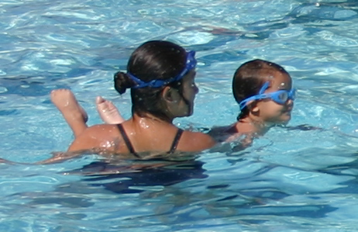



June 28 – July 23
4 weeks, 16 classes
Mon, Tues, Wed & Fri
11am – 12:15pm
$55 per person *fee includes t-shirt
Ages: 11-15

Jr. Lifeguard Competition: July 24

Special Thanks to Our 2009 Competition Sponsors!

Session I-IV ~ 2 weeks, 8 lessons
Mon, Tues, Wed & Fri
9am – 9:45am
10am – 10:45am
11am – 11:45am

$25 per person / per session

LEARN 2 SWIM

July 26 – August 6

2 weeks, 8 lessons
Mon, Tues, Wed & Fri
7:15 pm – 8:00 pm

$25 per person

REGISTRATION: Saturday, July 24 @ 1pm

Friday – Wednesday

SESSION I 1:00pm – 3:55pm

SESSION II 4:05pm – 7:00pm

Admission $1 per person/per session

Closed Thursday

Family Night

Saturday ~ 7:05pm – 9:00pm

Pool Operating Dates: May 29 - Labor Day Weekend

SESSION I May 31 ~ June 11

SESSION II June 14 ~ June 25

SESSION III June 28 ~ July 9

SESSION IV July 12 ~ July 23

REGISTRATION: Saturday Before Session Starts
May 29 ☼ June 12 ☼ June 26 ☼ July 10
9am – 11am
City Policy: Cash or Money Order Only at time of Registration all lessons are on a 1st come / 1st serve basis ~ a minimum of 6 students is required to form a class

LAP SWIM & AQUA WALK ~ available by appointment only
The La Feria Aquatic Center strives for safety in and around the water; therefore, lifeguards are always on duty during operating hours. All lifeguards are trained and certified by the American Red Cross.
FOR MORE INFORMATION ON ALL GREAT PROGRAMS OFFERED call 797-4669/797-2261
Reserve your Pool Party at 797-4669 ☼ Proper Swimwear is Required by All Patrons

June 14 – June 25
2 weeks, 6 lessons ~ Mon, Wed & Fri
7pm - 7:30pm $25 per child

Session I – IV
2 weeks, 6 lessons

Mon, Wed & Fri

7:05pm – 7:50pm
8:00pm – 8:45pm

$50 per person / per session
ADULT SWIM LESSONS
June 15 – July 20
6 lessons, Tuesday ~ 7:05 pm – 8:15 pm
$30 per person ~ Beginners - Advanced

